# Week 11: Coursework

## Angular Framework

1. Create a new Angular application using Angular CLI. This application will offer a to-do list with adding and removing functions.
2. In the *app’s* component HTML template, you have to create the following:
   1. An HTML *<input type=”text”>* to input the task’s name.
   2. An HTML button to trigger the adding event.
   3. A table to show the tasks you added to the to-do list.
   4. Each row in the table has a remove button to remove itself.
   5. Use the figure below as a reference.

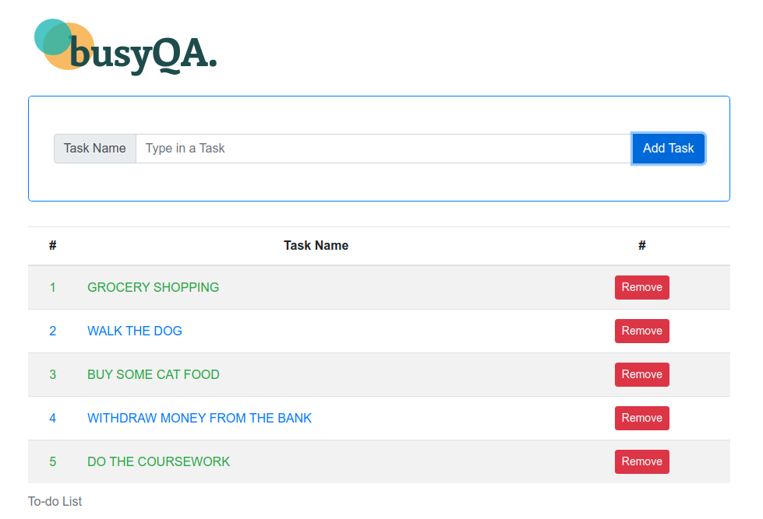

1. In the *app’s* component TS file, you have to create the following:
   1. A variable associated with using two-way binding to the HTML *<input type=”text”>* specified in step two. Hint: Use *[ngModel]*. Also, add the *FormsModule* to the application’s *AppModule* *imports* array to enable *[ngModel]* in the application.
   2. An array called *tasks* that holds the list of tasks.
   3. A method called on*AddTask*() that adds a task to the tasks array. We should clean the task variable after adding the task to the list. Hint: Use the push() method of the array.
   4. A method called onDeleteTask() that removes a task from the tasks array. Hint: Use the splice() method of the array.
2. Also, consider:
   1. An HTML table displays the tasks list. Hint: Use *ngFor.
   2. The odd rows in the table use green fonts, and the even rows use blue fonts. Hint: Use ngClass.
   3. We have to display a message when a task is added or deleted. Hint: Use *ngIf.
3. Add Bootstrap styles to make your application look more attractive.
4. After completing the project, test it, and create a new repository on GitHub, finally commit and push your application to GitHub.
5. You can find the solution for the project in the Github repo:

<https://github.com/busyQA-java-developer/busyqa-11-angular-3-coursework-complete.git>

// End